SELF-BUILDING REPORT

Netflix Content Strategy Analysis
Using SQL

A Data Analysis Project on Netflix
Global Content Library

Prepared by
Name - Aradhna Barve

MBA Student
Maulana Azad National Institute of Technology

03 March 2026
S. No. | Content | Pg No.
1 | Introduction | 1
2 | Objective of the Study | 2
3 | Dataset Description | 3
4 | Methodology | 4
5 | SQL Analysis | 5-6
6 | Conclusion | 7

- INTRODUCTION
Over the past decade, digital streaming platforms have transformed the global entertainment industry by changing how audiences access and consume media content. Among these platforms, Netflix has emerged as one of the most influential players, offering a vast library of movies, television shows, documentaries, and original productions to viewers across the world. With millions of subscribers spanning multiple countries and cultures, Netflix’s success largely depends on its ability to curate a diverse and engaging content catalog that appeals to a wide range of audiences.

Data analysis plays an important role in uncovering such insights. By examining large datasets related to media content, analysts can identify patterns in production trends, genre preferences, geographic contributions, and audience targeting strategies. These insights can help explain how streaming platforms structure their content portfolios and how they adapt to evolving consumer demand.

This project aims to analyse Netflix’s content catalogue using Structured Query Language (SQL). The dataset used for this analysis contains information about thousands of titles available on the platform, including details such as the type of content, production country, release year, rating classification, and genre category. Through a series of SQL queries and exploratory analysis, the study investigates key patterns within the dataset to better understand the distribution and growth of Netflix’s content library.

The analysis focuses on several important aspects of the dataset. These include examining the proportion of movies and television shows, identifying the countries that contribute the most content to the platform, studying trends in content releases over time, and exploring the most common genres and rating categories. By analysing these elements, the project seeks to highlight how Netflix’s catalogue has evolved and how its content strategy reflects broader trends in the global entertainment industry.

Ultimately, the purpose of this project is not only to demonstrate how SQL can be used for data analysis but also to turn data findings into meaningful business insights. By combining technical data querying with analytical interpretation, the project offers a clearer view of how Netflix structures its content offerings to serve a global and diverse audience.

- OBJECTIVE OF THIS STUDY
This project specifically aims to use Structured Query Language (SQL) to explore and analyse a dataset containing information about Netflix titles. By applying SQL queries to the dataset, the study seeks to identify meaningful patterns and trends related to content types, geographic production distribution, release timelines, genre classifications, and audience ratings.
Another important objective of this analysis is to demonstrate how data analysis tools can be used to extract insights from real-world datasets. Through systematic querying and interpretation of the data, the project highlights how analytical techniques can support better understanding of business strategies within the digital entertainment industry.
More specifically, the study aims to achieve the following objectives:
• To examine the distribution of movies and television shows available on Netflix.
• To identify the countries that contribute the highest number of titles to the platform.
• To analyse trends in content release over time and understand the growth of Netflix’s content library.
• To explore the most common genres and categories of content available on the platform.
• To study the distribution of content ratings in order to understand the target audience of Netflix programming.

- DATASET DESCRIPTION
The dataset used in this project is the Netflix Titles Dataset, which contains information about movies and television shows available on Netflix. The dataset was obtained from the public data platform Kaggle, where it is commonly used for data analytics and machine learning. learning practice.
Dataset Source:
https://www.kaggle.com/datasets/shivamb/netflix-shows
The dataset provides structured information about Netflix’s content library, including details such as the title of the content, its type (movie or television show), production country, release year, genre classification, and audience rating. These attributes make the dataset suitable for exploring patterns related to content distribution, geographic production trends, and the evolution of streaming media content over time.
The dataset contains approximately 8,800 records, with each row representing an individual Netflix title. Each record includes multiple variables that describe different characteristics of the content.

- Methodology
The study adopts a quantitative exploratory data analysis methodology to examine patterns within the Netflix titles dataset. The methodological approach followed in this project is outlined below:
1. Type of Methodology
• The study uses quantitative exploratory data analysis (EDA).
• This approach focuses on analysing numerical and categorical data to identify trends, distributions, and patterns.
• Structured Query Language (SQL) is used as the primary analytical tool to perform the analysis.
2. Data Source
• The dataset used in this study is the Netflix Titles Dataset obtained from Kaggle.
• The dataset contains information about movies and television shows available on Netflix.
• Dataset link:
https://www.kaggle.com/datasets/shivamb/netflix-shows
3. Data Import and Storage
• The dataset was downloaded in CSV format.
• It was imported into MySQL Workbench, which served as the relational database management system for this analysis.
• A database schema and table structure were created to store the dataset.
4. Data Exploration and Preparation
• Initial exploration of the dataset was performed using SQL commands.
• The dataset structure, column names, and number of records were examined.
• Missing or inconsistent values were identified and addressed where necessary.
5. Limitations of the Methodology
• The dataset represents only the titles listed in the Kaggle dataset and may not include the complete Netflix catalogue.
• Some variables contain missing values, particularly for directors and production countries.
• The analysis focuses on descriptive patterns and does not include predictive modelling or viewer behaviour analysis.
- SQL ANALYSIS
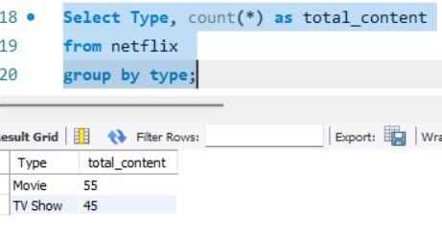
Analysis 1: Distribution of Content Type on Netflix
The analysis shows that movies represent a slightly larger portion of the Netflix content in the dataset compared to television shows. While both categories are well represented, movies make up the majority of titles available.

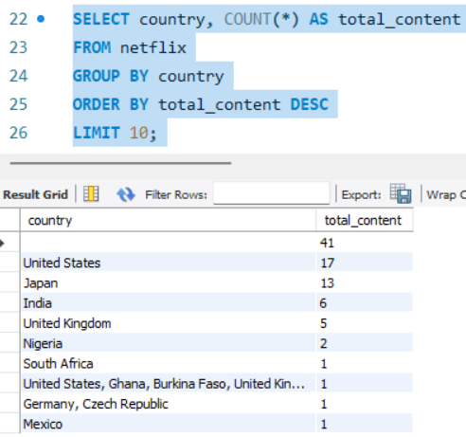
Analysis 2: Top Content Producing Countries on Netflix
The results indicate that the United States contributes the largest number of titles in the dataset, followed by Japan and India. Other countries such as the United Kingdom, Nigeria, and South Africa also contribute smaller portions of content.

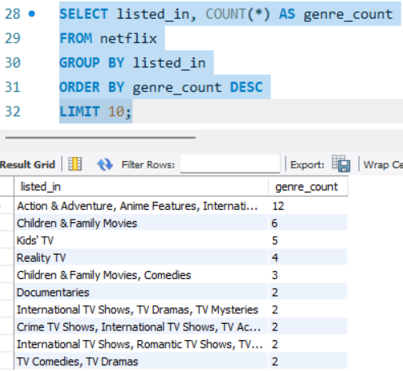
Analysis 3: Most Common Genres on Netflix
The analysis shows that Netflix hosts a diverse range of genres, with action-oriented and international content appearing frequently in the dataset. Categories such as children's content, reality television, and family-oriented programming also appear prominently, reflecting Netflix’s effort to cater to audiences across different age groups and interests.
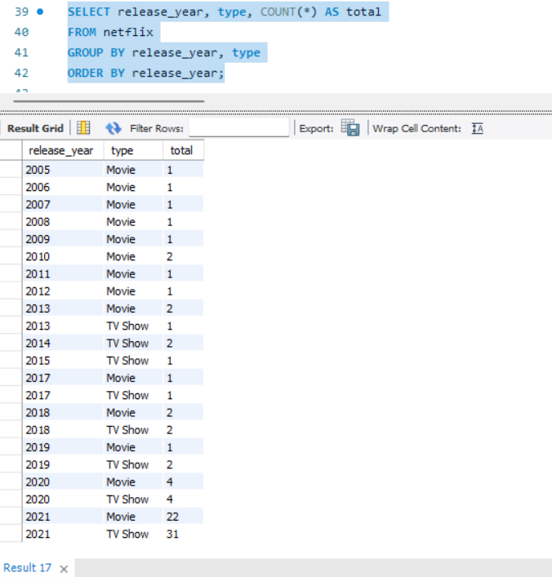
Analysis 4: Content Release Trend by Year
Year | Content Type | Total Titles
2005–2012 | Mostly Movies | Low volume
2013 | Movies & TV Shows | Beginning of  diversification
2018 | Movies & TV Shows | Increased production
2020 | Movies (4) | TV Shows (4)
2021 | Movies (22) | TV Shows (31)

The analysis shows that the number of Netflix titles released per year has increased significantly over time. Early years in the dataset contain only a small number of movies, but later years show a rapid increase in both movies and television shows.

- CONCLUSION

The analysis of the Netflix titles dataset using SQL provided insights into the distribution and characteristics of content available on the platform. The results show that movies slightly dominate the catalogue, while television shows also represent a significant portion of the content library. Country-wise analysis indicates that the United States contributes the largest number of titles, followed by other international markets such as Japan and India.
Additionally, the dataset highlights the diversity of genres available on Netflix and the increasing number of titles released in recent years. Overall, the analysis demonstrates how SQL can be used to explore and interpret large datasets, providing useful insights into content distribution and streaming platform strategies.

